jspInit()

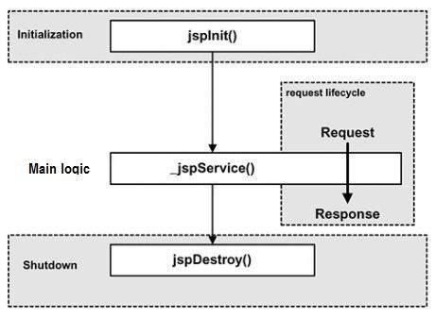

jspInit() is called when a Java Server Page is first executed and before the JSP starts serving requests.

The jspInit() should contain any initialization code required for the JSP (like a network connection or database initialization).

Syntax Example:

<%! public void jspInit() {

// any code required for initialization // should go here!

}

%>